

Introduction to Database Management Systems Lab

ENBC252

CLASS MANUAL

Submitted By: | Submitted To:
Naman Katewa | Ms. Rishika Mehta
2401830002 | Assistant Professor
B.Sc. (H) Cybersecurity | SOET

INDEX

Experiment No. | Experiment Title | Page No. | Date | Signature
1 | ERD Diagrams
2 | Select, From, Where
3 | Joins
4 | Group By, Order By, Having, Aggregate Functions
5 | Non-Correlated Nested Queries

Class Manual 1

ERD
An ERD (Entity Relationship Diagram) is used to represent the logical structure of a database. It consists of entities, attributes, and relationships.

Entity: A real-world object (e.g., Student, Course)
Attribute: Properties of entities (e.g., Name, ID)
Primary Key: Unique identifier for an entity
Relationship: Association between entities
Cardinality: Defines the number of relationships (1:1, 1:N, M:N)

University System ERD
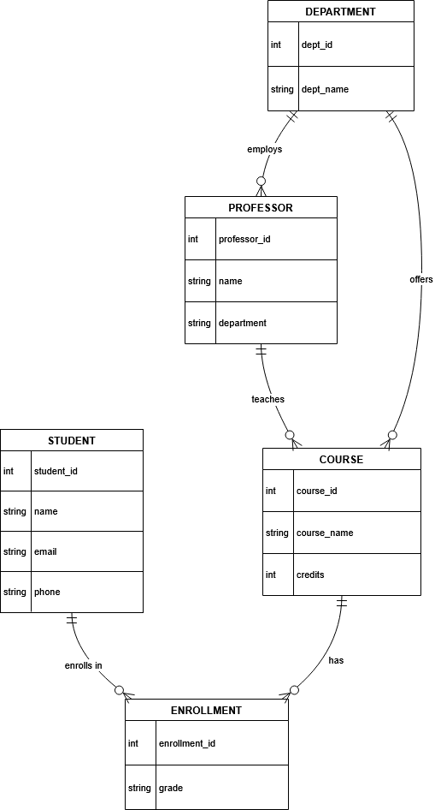
Library System ERD
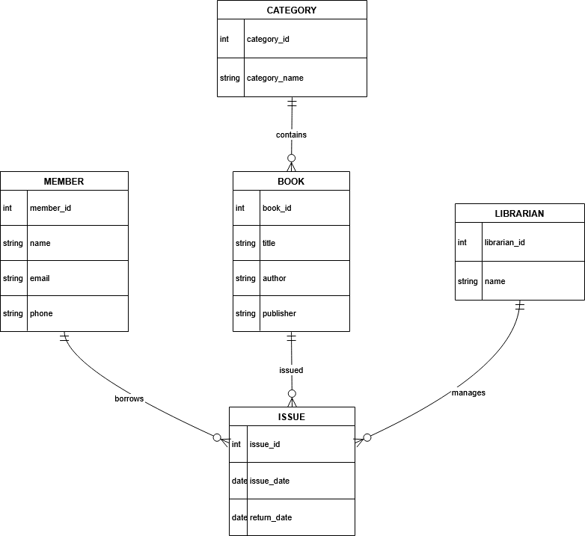

Class Manual 2
- Find out students with multiple enrollments

QUERY

SELECT S.name, COUNT(E.course_id) AS total_courses
FROM STUDENT S
JOIN ENROLLMENT E ON S.student_id = E.student_id
GROUP BY S.name
HAVING COUNT(E.course_id) > 1;

OUTPUT
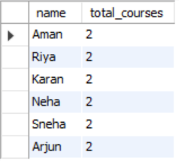

- Find out best grade per course

QUERY

SELECT C.course_name, MAX(E.grade) AS best_grade
FROM ENROLLMENT E
JOIN COURSE C ON E.course_id = C.course_id
GROUP BY C.course_name;

OUTPUT
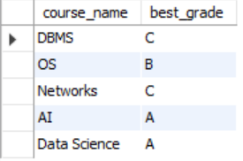

Class Manual 3

- Display all students & courses with enrollment status

QUERY

SELECT S.name AS student_name,
C.course_name,
CASE
WHEN E.student_id IS NULL THEN 'Not Enrolled'
ELSE 'Enrolled'
END AS status
FROM STUDENT S
CROSS JOIN COURSE C
LEFT JOIN ENROLLMENT E
ON S.student_id = E.student_id
AND C.course_id = E.course_id;

OUTPUT
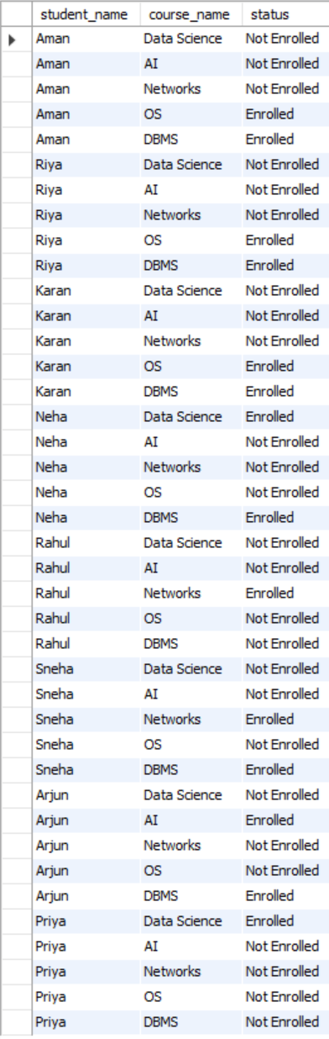
- Find courses taught by professors with more than 1 section

QUERY

SELECT P.name AS professor_name,
C.course_name,
COUNT(T.section) AS total_sections
FROM TEACHES T
JOIN PROFESSOR P ON T.professor_id = P.professor_id
JOIN COURSE C ON T.course_id = C.course_id
GROUP BY P.name, C.course_name
HAVING COUNT(T.section) > 1;

OUTPUT
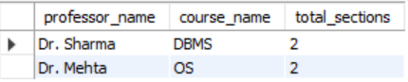

- Count all possible student course pairs

QUERY

SELECT COUNT(*) AS total_pairs
FROM STUDENT S
CROSS JOIN COURSE C;

OUTPUT
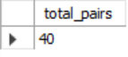

Class Manual 4

- Count students per course (sorted by popularity)

QUERY

SELECT C.course_name, COUNT(E.student_id) AS total_students
FROM COURSE C
LEFT JOIN ENROLLMENT E ON C.course_id = E.course_id
GROUP BY C.course_name
ORDER BY total_students DESC;

OUTPUT
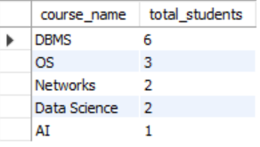

- Find courses with low enrollment (including zero)

QUERY

SELECT C.course_name, COUNT(E.student_id) AS total_students
FROM COURSE C
LEFT JOIN ENROLLMENT E ON C.course_id = E.course_id
GROUP BY C.course_name
HAVING COUNT(E.student_id) <= 1
ORDER BY total_students ASC;

OUTPUT
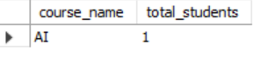

- Find average CGPA per course for enrolled students

QUERY

SELECT C.course_name, ROUND(AVG(S.cgpa), 2) AS avg_cgpa
FROM ENROLLMENT E
JOIN STUDENT S ON E.student_id = S.student_id
JOIN COURSE C ON E.course_id = C.course_id
GROUP BY C.course_name;

OUTPUT
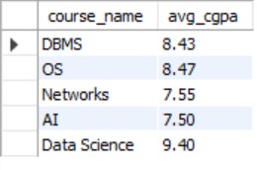

- Display grade distribution per student (highest CGPA first)

QUERY

SELECT S.name, S.cgpa, C.course_name, E.grade
FROM STUDENT S
JOIN ENROLLMENT E ON S.student_id = E.student_id
JOIN COURSE C ON E.course_id = C.course_id
ORDER BY S.cgpa DESC;

OUTPUT
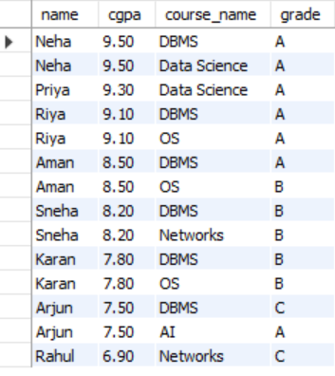

- Find out high CGPA courses with enrollment > 1

QUERY

SELECT C.course_name,
ROUND(AVG(S.cgpa), 2) AS avg_cgpa,
COUNT(*) AS total_students
FROM ENROLLMENT E
JOIN STUDENT S ON E.student_id = S.student_id
JOIN COURSE C ON E.course_id = C.course_id
GROUP BY C.course_name
HAVING COUNT(*) > 1
ORDER BY avg_cgpa DESC;

OUTPUT
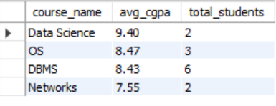

Class Manual 5

- Find students enrolled in courses taught by Dr. Smith.

QUERY

SELECT name
FROM Student
WHERE student_id IN (
SELECT student_id
FROM Enrollment
WHERE course_id IN (
SELECT course_id
FROM Course
WHERE professor_id = (
SELECT professor_id
FROM Professor
WHERE professor_name = 'Dr. Smith'
)
)
);

OUTPUT
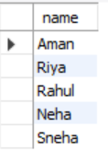

- Find courses whose enrollment is greater than minimum enrollment among all four courses.

QUERY

SELECT course_id, course_name
FROM Course
WHERE course_id IN (
SELECT course_id
FROM Enrollment
GROUP BY course_id
HAVING COUNT(*) > (
SELECT MIN(cnt)
FROM (
SELECT COUNT(*) AS cnt
FROM Enrollment
GROUP BY course_id
) AS temp
)
);

OUTPUT
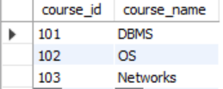

- Find students whose CGPA is among top 3 highest CGPA

QUERY

SELECT name, cgpa
FROM Student
WHERE cgpa IN (
SELECT cgpa
FROM (
SELECT DISTINCT cgpa
FROM Student
ORDER BY cgpa DESC
LIMIT 3
) AS temp
);

OUTPUT
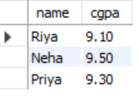

- Display courses that have no students enrolled.

QUERY

SELECT course_name
FROM Course
WHERE course_id NOT IN (
SELECT DISTINCT course_id
FROM Enrollment
);

OUTPUT
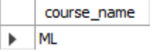

- Find students who are enrolled in every course offered.

QUERY

SELECT name
FROM Student
WHERE student_id IN (
SELECT student_id
FROM Enrollment
GROUP BY student_id
HAVING COUNT(DISTINCT course_id) = (
SELECT COUNT(*) FROM Course
)
);

OUTPUT

No Students

- List courses where maximum grade is greater than average grade for all courses.

QUERY

SELECT course_name
FROM Course
WHERE course_id IN (
SELECT course_id
FROM Enrollment
GROUP BY course_id
HAVING MAX(grade) > (
SELECT AVG(grade) FROM Enrollment
)
);

OUTPUT
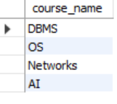

- Find students who are not enrolled in any course.

QUERY

SELECT name
FROM Student
WHERE student_id NOT IN (
SELECT DISTINCT student_id
FROM Enrollment
);

OUTPUT
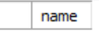
No students

- Display courses having highest number of enrollments.

QUERY

SELECT course_name
FROM Course
WHERE course_id IN (
SELECT course_id
FROM Enrollment
GROUP BY course_id
HAVING COUNT(*) = (
SELECT MAX(cnt)
FROM (
SELECT COUNT(*) AS cnt
FROM Enrollment
GROUP BY course_id
) AS temp
)
);

OUTPUT
